Town Awarded MassTrails Grant for Construction of Haggett’s Pond Rail Trail
Bartlet Street Dispatch June 21, 2023
Town of Andover Newsletter
June 21, 2023 | No. 011

Subscribe

Haggett’s Pond Rail Trail
Town Awarded MassTrails Grant for Construction of Haggett’s Pond Rail Trail

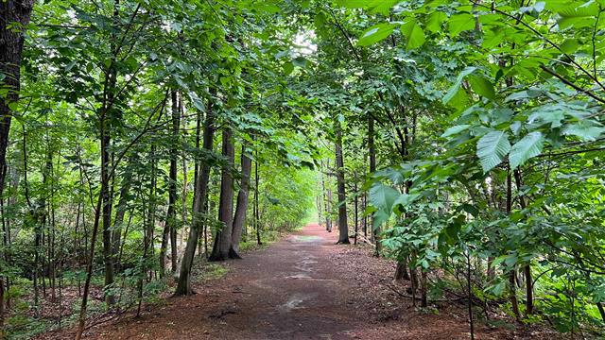

ANDOVER, MA - On Wednesday, June 14, Lieutenant Governor Kim Driscoll announced that the Town of Andover has been awarded a $500,000 grant through the Commonwealth’s MassTrails Grant Program for the construction of the Haggett’s Pond Rail Trail. The project will convert the railbed along the western border of Haggett’s Pond to a paved multi-use path that will extend approximately 4,500 feet from Haggett’s Pond Road to a new boardwalk overlooking the pond.

The goal of the project is to improve the existing trail at Haggett’s Pond to make it more welcoming and usable to all town residents. The 10 to 12-foot paved trail proposed at the site will be ADA accessible, providing opportunities for persons of all abilities to enjoy Haggett’s Pond and the pristine environment that surrounds it. When completed, the trail will be the first Town-sponsored accessible and ADA compliant trail in Andover, making it a cornerstone of accessible recreational opportunity in the community.

In addition to the paved path, the Haggett’s Pond Rail Trail project is anticipated to include the installation of new benches and signage containing information about Haggett’s Pond, the Andover Water Department, native plants and wildlife species that can be observed around the pond, and the history the rail transport in Massachusetts. The trail will end at a boardwalk leading to an overlook offering a scenic vantage point of the pond.

Construction of the 4,500-foot paved trail represents the first step in a broader effort to strengthen Andover’s trail system. A long-term plan of the Town of Andover seeks to develop a 3.5 mile stretch of trail that will link sections of the Bay Circuit Trail and enhance access to recreational assets throughout Andover. This plan is anticipated to be carried out in phases throughout future years.
The creation of an inclusive trail at Haggett’s Pond has been an objective of the Town of Andover for several years. The project was listed as a priority in the Town’s 2012 Master Plan. In 2016, the Town completed a review for inclusive design of the rail trail, a comprehensive process that involved the participation of Town departments and residents with physical, sensory and cognitive functional limitations.

Janet Nicosia, Andover’s Director of Facilities, led the Town’s application to MassTrails Grant Program along with Director of Public Works Christopher Cronin. Nicosia attended a grant announcement ceremony held in Billerica on behalf of the Town of Andover along with Deputy DPW Director Carlos Jaquez, and Commission on Disability Chair Justin Coppola.

“The construction of an accessible trail at Haggett’s Pond has been a long-standing priority for the Town of Andover and the community, and we are extremely grateful that it has been selected to be funded through the MassTrails Grant Program,” said Nicosia. “This transformative project will expand recreational opportunities for all members of our community, regardless of their physical abilities, and make it easier to access and enjoy Haggett’s Pond – one of Andover most striking natural assets. We look forward to beginning construction of this project and eagerly anticipate welcoming residents and visitors to the trail.”

The Town of Andover’s Commission on Disability has long held the creation of an accessible trail as a priority, and was active in supporting the Town’s application for the MassTrails grant.

“This award is a great milestone in the Andover Commission on Disability’s goal of ADA Program Access: to ensure that all of the town programs, services, and activities, when viewed in their entirety, are accessible to people with disabilities,” said Commission on Disability Chair Justin Coppola. “The Andover Commission on Disability has been collaborating with the Town since the beginning of this project and we are proud that we could help in obtaining this grant. A group of Andover residents ranging from nine to ninety-four with a mix of physical, sensory and cognitive functional limitations did a walking tour with Town Staff and provided input about their issues in navigating this environment.”

The MassTrails Grant Program provides matching grants, technical assistance, and resources to individuals, municipalities, non-profits, and other public entities. These funds go toward the design, construction, and maintenance of diverse, high-quality trails, including hiking trails, bikeways, and shared-use paths.

The program is funded through the Department of Conservation & Recreation’s capital budget and the Federal Highway Administration’s Recreational Trails program. Applications are reviewed by an inter-agency team comprised of representatives from MassDOT, EEA, DCR, and Massachusetts Recreational Trails Advisory Board. A total of $11.2 million in funding will be granted through the program this year, supporting 68 projects in communities across Massachusetts.

