A

The Newsletter of the Andover Commission on Disability

A

ccess

**September**, 2022

ndover

Andover

Commission

on Disability

Justin Coppola - Chair

Kathleen Dolan

David Kahan

Katherine Ananis

Jemma Lambert

Trish Leelman

Bernadette Lionetta

Eileen Reilly

Stephen Surette

Susan McKelliget - clerk

Liaisons:

Annie Gilbert,

Select Board

Gail Bloom,

Council on Aging

Janet Nicosia,

ADA Coordinator

and Facilities Director

Ellen Townson,

Conservation Comm

Website

Acod.mhl.org

Email

acod.mhl.org/contact-us

**M**eetings

4th Wednesday

of the month.

At 6:30 PM

Meetings are

currently being

held virtually

All are Welcome!

Mission

To address Andover’s

disability needs for the

town and its residents,

visitors and families with disabilities.

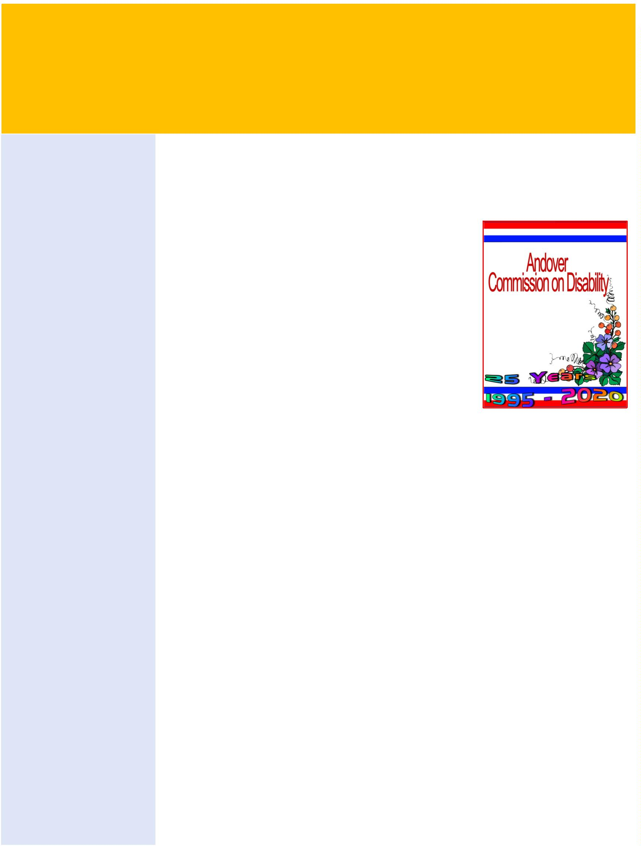

**Disability Awareness**

61 million people in the US have disabilities

Many with hidden disabilities

Mobility is the most common disability

2nd is Cognitive issues

3rd is the ability to live independently

Many resources available at the library and at the Commissions web: acod.mhl.org

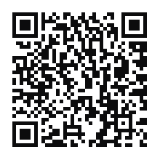

**Resources for Caregivers**

Attend one of the many Support Groups

AgeSpan One-on-one meetings available

Wide array of Library Materials mhl.org

Project Lifesaver for people who wander

Free Hospital Equipment Loan Program

Accessible Resources at acod.mhl.org

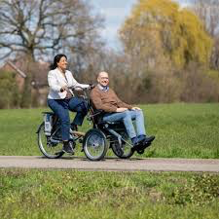 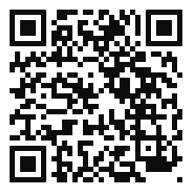

**10 Things to Know about**

**the Commission on Disability**

Advocates for people with disabilities

We advise and assist town officials

in addressing the needs of these people

We advocate for full integration

We sponsor projects for our constituents

We provide information and referrals



**Implicit (Unconscious) Bias**

Having Negative Attitudes

Without Conscious Awareness

Promote Implicit Bias Awareness

Challenge Preconceived Ideas

Many Library Materials are available

Accessible Resources at acod.mhl.org

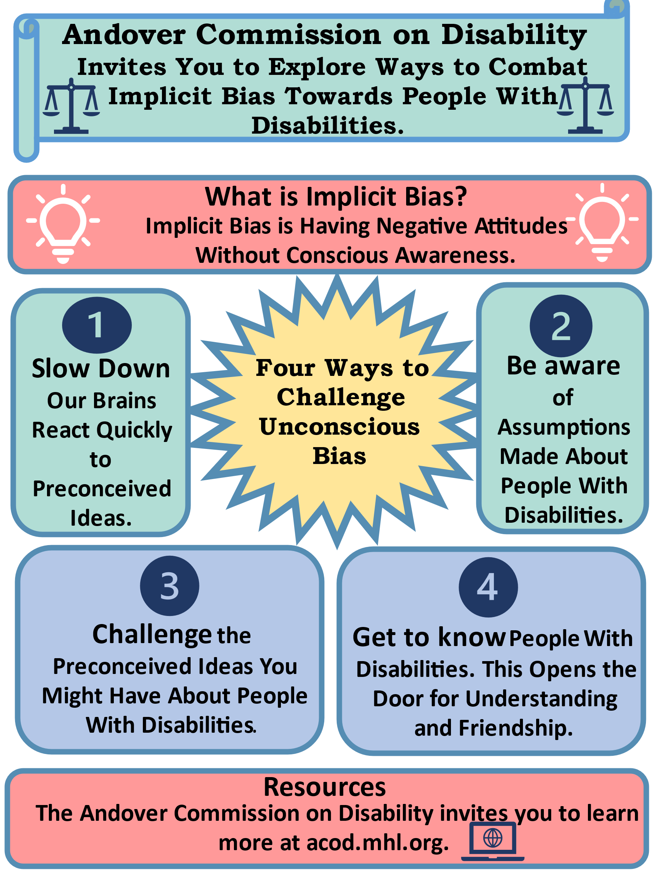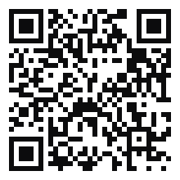

**Resources**

For Families and Individuals

**Project Lifesaver**

The premier search and rescue program operated internationally by public safety agencies. Designed for "at-risk" individuals prone to wandering. For more information contact Det. Robin Cataldo at the Andover Police Department 978.475.0411 x 1004.

**My Own Voice**

A community-based choir for children and adults with cognitive and/or physical disabilities. Contact Bernadette Lionetta at: [blionetts9@verizon.net](mailto:blionetts9@verizon.net) or visit: Facebook/treblechorusne.

**Emergency 911**

911 allows people to individually register with the Police Department by filling out a Disability Indicator Form. Call

978.475.0411 x 3028 for more information.

**School Accessibility Resources**

Check out the Andover Public Schools Special Education Procedural Manual and Andover Public Schools Special Education Parent Guide at: aps1.net or call the

Office of Student Services at:

978.247.7040.

**Library Accessible Resources**

are in-depth and available to anyone. Check out mhl.org/disabilities, call: 978.623.8430 or email [rdesk@mhl.org](mailto:rdesk@mhl.org).

**Free IDs**

For those without licenses issued by the

Essex County TRIAD. Call: 978.623.8321.

**Robb Center Accessibility Resources**

are available to all elders and their families in Andover. The new Robb Center is not only ADA compliant but offers a fully accessible workout room! Call 978.623.8320 or visit: https://andoverma.gov/227/Elder-Services.

**Andover Veterans Services**

Offers an array of programs and resources for disabled

Veterans and their families. For more information call:

978.623.8320 or visit:

https://andoverma.gov/234/Veteran-Services.

**Accessible Public Transportation**

Available through MVRTA’s "EZ Trans" program. Call 978.469.6878 or visit: mvrta.com/special services. Also, available

via MBTA Commuter Rail buses, and subways.

Visit: mbta.com/accessibility or call:

617.222.3200.

The Robb Center also offers an array

of individual accessible transportation options

available to the readers.

**Assistive Listening**

Check out Andover TV.org for closed captioning services on Andover’s Cable Access TV stations. Listen Everywhere is available at Town Meetings and will be available in Town facility conference rooms. Using smartphones. Instructions available at the individual locations.

**Mason's Hospital Equipment Loan Program**

**(HELP)** loans medical equipment for home use. Walkers, wheelchairs, etc. for those in need.

Pick-up/drop offs on Saturdays, 9:00 am-noon

at the Masonic Building in Woburn.

Call: 978.322.1052 or visit: smd-help.org.

